|  |  |
| --- | --- |
| Single Page Application on Task manager | Abstract  The Task Manager solution should be a Single Page Application (SPA) to keep track of upcoming tasks, finished tasks and their respective priorities.  Developer  MEAN Full Stack Developer |

# Wireframes

## Add Task

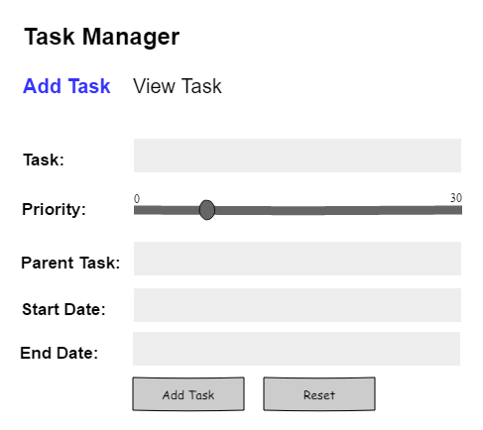

## View Task

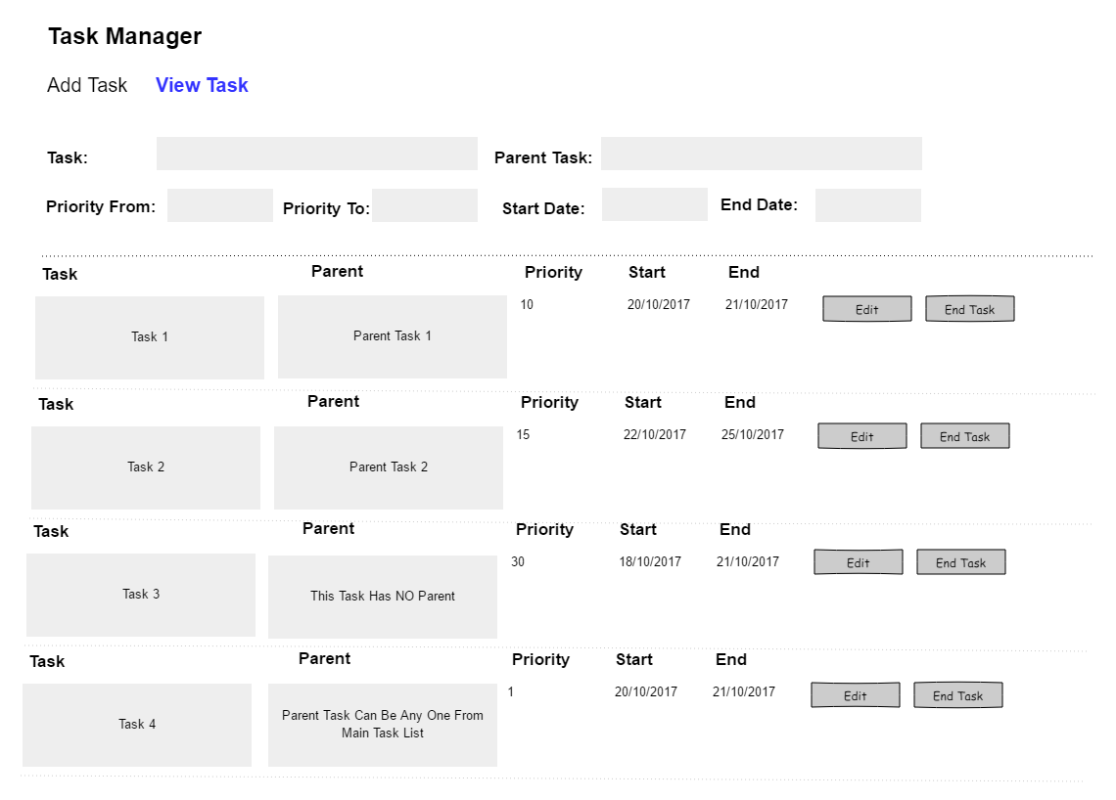

## Update Task

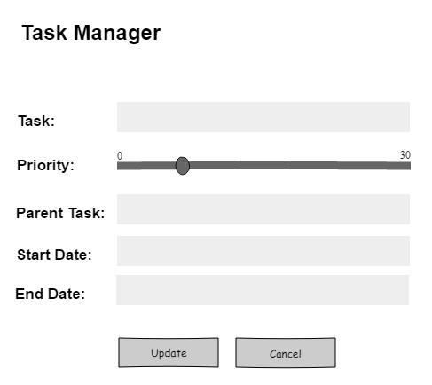

# Database Tables

|  |  |  |  |
| --- | --- | --- | --- |
| **Parent Task Table** |  | **Task Table** |  |
|  |  |  |  |
| Parent_ID |  | Task_ID |  |
| Parent_Task |  | Parent _ID |  |
|  |  | Task |  |
|  |  | Start_Date |  |
|  |  | End_Date |  |
|  |  | Priority |  |
|  |  | Finished |  |
|  |  |  |  |
|  |  |  |  |
|  |  |  |  |